Use-Case Realization Report
DeleteCustomer

Issue <1.0>
Revision History
Date | Issue | Description | Author
<02/08/09> | <1.0> | <DeleteCustomer> | <Karen Gao>

Table of Contents
1. Brief Description 4
2. Flow of Events 4
2.1 Standard Flow 4
2.2 Exceptions 4
3. Interaction Diagrams 5
3.1 Collaboration Diagram for Delete Customer 5
4. Participating Objects 5
5. Class Diagrams 6
5.1 Class Diagram for Delete Customer 6
6. Derived Requirements 6

Use-Case Realization Report
DeleteCustomer

Brief Description
The deletion of Customer shall be executed once the selection check for the existing Customer list was performed.

Flow of Events

Standard Flow
This use case covers the events of deleting Customer, which is part of the Customer Maintenance package. The standard flow of events is described as below:
- The Portal Administrator shall press the button to send out a command of “deleteButtonClicked” on the interface of CustomerPage.
- Once CustomerController received this request, the operation checkCustomerToDelete will check if there’s Customer seleted.
- Then the operation getCustomer will get the Customer from object of Customer.
- The operation deleteCustomer will delete the selected one from the list.
- Then the operation updateCustomerList of the CustomerController will update the new list of Customer object
- Once it’s done, the successful updating CustomerList will show to the CustomerPage.

Exceptions

- If there’s no selection found in Customer Admin records, a warning message will be show to the CustomerPage through the operation showNoCustomerSelectedMsg.

Interaction Diagrams

Collaboration Diagram for Delete Customer
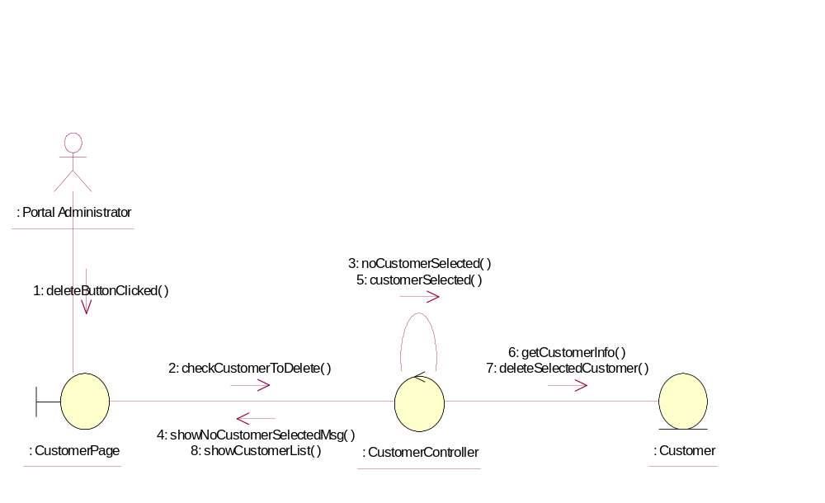

Participating Objects
: Customer
This Entity is Customer Object

: CustomerController
This controller is to add, delete and update Customer

: CustomerPage
This is a page for adding, deleting, updating and displaying the Customer

: Portal Administrator
This is the super user of system

Class Diagrams

Class Diagram for Delete Customer
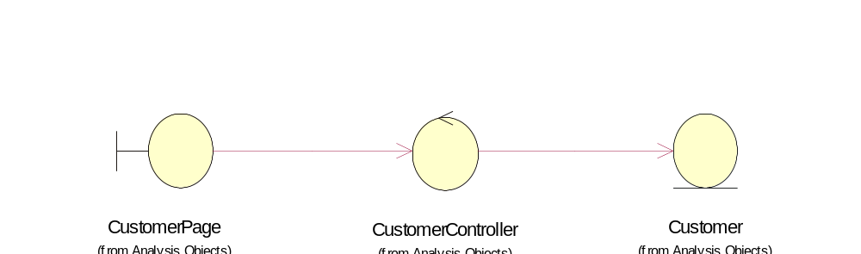

Derived Requirements
Only Portal Administrator has rights to access this page.

